National Climate Change Adaptation Research Facility:
Terrestrial Biodiversity Network
Application for Funding for a PhD Short Collaborative Visit
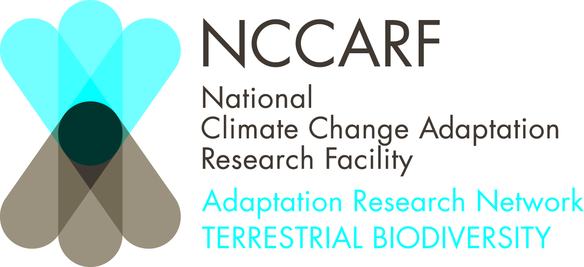

Student name:
Institution:
Supervisor (s):
Stage of PhD (time since started):

Title of PhD project:

Contact details (including email):

Researcher and Institution in which collaboration/travel will take place:

PhD Project description (maximum 1/2 page):

Explain how your PhD project will directly inform management or assist in natural adaptation of terrestrial biodiversity to climate change. (up to ½ page A4)

How does this project address priority issues outlined in the National Adaptation Research Plan for Terrestrial Biodiversity? (up to ½ page A4) available at (see pages 29-44) http://www.nccarf.edu.au/sites/default/files/TB%20NARP%20Final.pdf

Describe what will be undertaken during your visit ( what you want to do and why; up to ½ page A4):

Explain how this collaboration visit will increase your skills and knowledge base, including why the research cannot be carried out at your host institution, if international travel is to be undertaken please explain why this could not be done nationally (up to ½ page A4):

Summary of support request (including a detailed breakdown of the amount being requested, justification):

We will not fund pure climate change impacts research, or research that is not related to Terrestrial Biodiversity.
Your application must show a strong case for directly informing alternative management options or assisting in natural adaptation of terrestrial biodiversity to climate change. A statement that "this research will inform management" is not enough.

