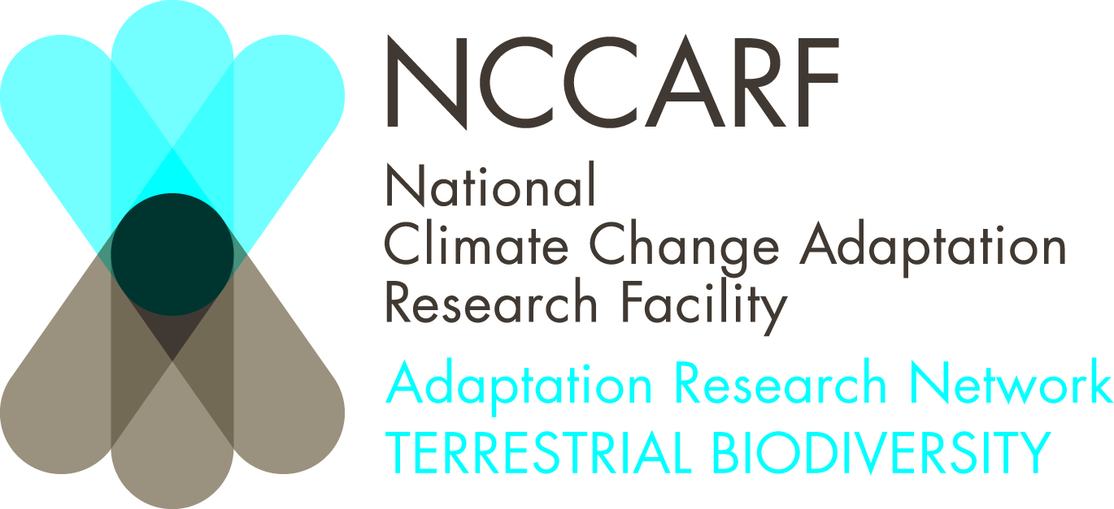

Honours and Masters research grants

A total of 10 honours / masters research grants valued at $7,000 each will be offered by the National Climate Change Adaptation Research Facility – Terrestrial Biodiversity Adaptation Research Network. Applications will be accepted in a wide range of disciplines however the research undertaken must be relevant to the area of climate change adaptation for Terrestrial Biodiversity.

Applicants must be domestic students undertaking a full-year research project. Applicants from any Australian university may apply. If all grants are not given in this round another may be advertised later in the year, however there is no guarantee of a second round offer.

Eligibility

- This round is open to full time and part-time domestic students of Australian Universities in any discipline.
- Students must be undertaking a full-year research project (may be undertaken over two years part time)
- Research must directly inform management or assist in natural adaptation of terrestrial biodiversity to climate change
- Applicants must commence their Honours / Masters research program during 2011 and show proof of acceptance to an Australian University honours /masters program.

Inclusions

- NCCARF – Terrestrial Biodiversity Honours/Masters grants valued at up to $7000 are available.
- Each grant will consist of three payments: 1) $5000 on commencement of the project, 2) $1000 on receipt of finished thesis (both hardcopy and electronic) and 3) $1000 on submission of a manuscript to an appropriate journal.
- Grant funds may only be used to cover research cost and a small portion for attending a domestic conference and/or presenting at the NCCARF conference.
We will not fund pure climate change impacts research, or research that is not related to Terrestrial Biodiversity.
Your application proposal must show a strong case for directly informing alternative management options or assisting in natural adaptation of terrestrial biodiversity to climate change. A statement that "this research will inform management" is not enough.

Application

Student details (1 page)
Name
Student ID number
Contact details –phone/email/ mail address
University at which project is to be undertaken
Proof of acceptance into relevant Uni honours/masters program
Contact details of research office
Supervisor(s) name(s)
Supervisors contact details
Signature of supervisors showing their willingness to supervise this student and project (and submit report upon student failure to do so)
- Academic transcript – one certified copy
- Project proposal (not exceeding two pages - any pages beyond this will not be read by review panel). This should include –
  - Brief background
  - Relevance to climate change adaptation and management of terrestrial biodiversity
  - Methods
  - Brief budget and justification
  - Expected projects outcomes
  - Brief timeline (can be separate page from above showing commencement/completion and reporting dates of project)

Selection Criteria

- Applicant ability to undertake research and demonstrated academic record.
- Relevance of the research to the goals and outcomes of the NCCARF – Terrestrial Biodiversity Network and climate change adaptation for terrestrial biodiversity
- Quality and nature of the proposed project
- Overall quality of the application

Reporting

- A two page summary report must be submitted within one month of completion of honours project. If this is not submitted by student then it will be the responsibility of the supervisor or they will not be able to apply for further support. Report to include – major findings and outcomes of the project, significance to adapting and protecting Australias terrestrial biodiversity and further research suggestions.
- A hard copy and electronic copy of the thesis (expenses to be covered by the scholarship) to be submitted to the TB network upon completion of the project.

The NCCARF – TB network reserves the right to publish the report (full, or extracts) on its web site and in its publications. The NCCARF – TB network requires acknowledgement of the research grant in the thesis document, and in any publications or presentations made concerning the project.

This application must be emailed to Yvette Williams as a separate PDF or word document. Applicants will be notified of the success of their project application by email.

Yvette Williams
James Cook University
Townsville
Yvette.Williams@jcu.edu.au
Ph: 07 4781 5552

